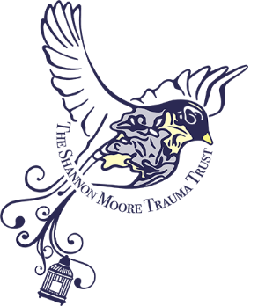 | Shannon Moore Trauma Trust  Children and Young Peoples’  Privacy Notice:
THE INFOMRATION WE KEEP ABOUT YOU:
There are important laws that tell us how to protect the information we have about you. This leaflet tells you all about it.

WHY DO YOU HAVE INFORMATION ABOUT ME?
We need to keep information about you because you or your parents/carers have asked for some money to pay for services that will hopefully help you feel better about things.
We need to keep a record of what we do and what we know about you in the process of making a decision about whether or not we can give you that money.
That decision is made by a few people who run the Charity which holds the funding and only they will see the information about you.

WHAT INFORMATION DO YOU HAVE ABOUT ME? We keep a record of things like:
- Your name and age
- Your parent/carers’ names
- Your address and school
- Telephone numbers for your parent/carers
- Your family background
- Whether you have seen a therapist before
- Worries that adults who care about you might have and what they and you might like to be different to feel better
- Whether you or your family is religious
- Anything else that you or your parent/carers think is important for us to know to better understand how things are for you.

CAN YOU GIVE MY INFORMATION TO ANYONE ELSE?
We are not allowed to share your information with other people outside of the Charity, unless your parent/carers have told us that we can.
The only time we will share any information about you without your parent/carer’s knowledge is if we feel something they or you have told us puts you at risk. Then we will give information to Children’s Social Care to consider if they need to do anything to make you or your family safer.
With your parent/carer’s consent and only if you are granted the money to get some help, we will share your details with the therapy service who will meet with and help you.

HOW LONG WILL YOU KEEP MY INFORMATION FOR?
We will look after the information we have about you until three months after any application for funding has been considered and an outcome to decline or provide funding has been given. This is just to ensure that any funding application has been fully concluded, and be sure that everyone knows the outcome.

YOUR PARENTS / LEGAL GUARDIANS ARE ALLOWED TO:
- Ask to see the information we have about you. We may share it with them, or we may let them know that we cannot share the information because we think doing so might cause harm to someone.
- Tell us if our information is not correct.
- Ask that we delete your information. We may say yes to this, or we may let them know that we need to keep the information. If you are over 13 years old, you may be allowed to say ‘no’ to your parents/carers seeing the information we have about you.

OUR TOP PRORITY:
We know it is really important that the information we have about you is protected and kept really safe. You can trust us to look after it really carefully.

If you want to talk to someone at the Charity about the information we have about you, the person to speak to is Shoshanah Lyons. It is Shoshanah’s job to make sure the information is kept safe, and she can answer any questions. You can contact her by writing to the Charity via: shoshanah.lyons@traumatrust.co.uk or emailing the charity via office@traumatrust.co.uk

Approved February 2025

